CHAPTER 4: Interval Estimation in R

Structure: Point Estimate ± Margin of Error

Margin of Error = Critical Value × Standard Error

- Confidence Interval (CI) for Proportion
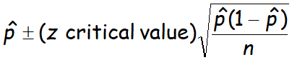
# Example: 192/594 parents buckle toddlers
n = 594
k = 192
pbar = k/n
se = sqrt(pbar*(1-pbar)/n)
cv = qnorm(0.975)
# 95% CI
errmargin = se*cv
pbar + c(-errmargin, errmargin)

# OR use built-in (conf.level=0.95 default):
prop.test(k, n)

- CI for Mean (known Variance, σ²)
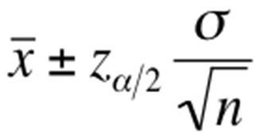
# Example:
n = 25
stdDev = 75
x = c(235, 374, 309, 499, 253, 421, 361, 514, 462, 369, 394, 439, 348, 344, 330, 261, 374, 302, 466, 535, 386, 316, 296, 332, 334)
xbar = mean(x)
se = stdDev/sqrt(n)
cv = qnorm(0.975)
errmargin = cv*se
xbar + c(-errmargin, errmargin)

CHAPTER 5: Hypothesis Testing – 1 Sample in R

Two Decision Methods:
- Traditional (Critical Region) Method
If the test statistic falls inside the critical region → Reject H₀
If NOT in critical region → Fail to reject H₀

- P-value Method
If p-value ≤ α → Reject H₀
If p-value > α → Fail to reject H₀

Which test to use?
Testing proportion→Z-test | stat: z=(p̂−p)/√(pq/n) -> pnorm()/qnorm()
Mean, σ known→Z-test | stat: z=(x̄−μ)/(σ/√n) -> pnorm()/qnorm()
Mean, σ unknown→T-test | stat: t=(x̄−μ)/(s/√n), df=n−1 -> pt()/qt()
Variance test→Chi-square | stat: χ²=(n−1)s²/σ² -> pchisq()/qchisq()

- Proportion Test (One-Tailed)

# H₀: p=0.6, H₁: p<0.6, α=0.05
n=148
k=85
p=0.6
pbar = k/n
z = (pbar-p)/sqrt(p*(1-p)/n)
alpha = 0.05
## TRADITIONAL METHOD
z.alpha = qnorm(alpha)
# CV = -1.6449
# z=-0.638 > -1.645 → Fail to reject H₀
## P-VALUE METHOD
pval = pnorm(z)
# 0.2619
# pval 0.26 > 0.05 → Fail to reject H₀

- Mean Test – Known Variance, σ² (One-Tailed)

# H₀: μ=210, H₁: μ>210, α=0.05
n=40
sd=54.5
xbar=252.5
mu=210
alpha=0.05
z = (xbar-mu)/(sd/sqrt(n))
# z=4.93
## TRADITIONAL: right-tailed
z.alpha = qnorm(1-alpha)
# 1.645
# z=4.93 > 1.645 → Reject H₀
## P-VALUE: right tail → lower.tail=FALSE
pval = pnorm(z, lower.tail=FALSE)
# [1] 4.07e-07 < 0.05 → Reject H₀

- Mean Test – Known Variance, σ² (Two-Tailed)

# H₀: μ=15.4, H₁: μ≠15.4, α=0.05
n=35
sd=2.5
xbar=14.6
mu=15.4
z = (xbar-mu)/(sd/sqrt(n))
# -1.893
## TRADITIONAL: use α/2
z.alpha = qnorm(1-(alpha/2))
# ±1.96
c(-z.alpha, z.alpha)
# critical region -1.893 is NOT in {<-1.96, >1.96} → Fail to reject H₀
## P-VALUE: multiply by 2 for two-tailed
pval = 2*pnorm(z)
# [1] 0.0583 > 0.05 → Fail to reject H₀

- Mean Test – Unknown Variance, σ² (T-Test)

# H₀: μ=0.82, H₁: μ>0.82, α=0.05
x = c(0.8411, 0.8191, 0.8182, 0.8125, 0.8750, 0.8580, 0.8532, 0.8483, 0.8276, 0.7983, 0.8042, 0.8730, 0.8282, 0.8359, 0.8660)
n=15
s=sd(x)
mu=0.82
t = (mean(x)-mu)/(s/sqrt(n))
# 2.719
t.alpha = qt(1-alpha, df=n-1)
# 1.761
# 2.719 > 1.761 → Reject H₀
pval = pt(t, df=n-1, lower.tail=FALSE)
# [1] 0.0083 < 0.05 → Reject H₀

- Variance Test (Chi-Square)

# H₀: σ=3.7, H₁: σ<3.7, α=0.05
n=9
s.sd =3
sigma=3.7
alpha=0.05
x2 = ((n-1)*s.sd^2)/(sigma^2)
x2.alpha = qchisq(alpha, df=n-1)
# x2=5.26, x2.alpha=2.73
# 5.26 > 2.73 → Fail to reject H₀

Chi-Square Notes
Formula: χ² = (n−1)s² / σ²
df = n − 1
Use qchisq(α, df) for lower-tail CV
Use qchisq(1-α, df) for upper-tail CV

CHAPTER 6: Hypothesis Testing – 2 Samples in R

Tail Direction Guide
H₁: p₁ < p₂ → Left-tail
CV = qnorm(α) → negative

H₁: p₁ > p₂ → Right-tail
CV = qnorm(1−α) → positive

H₁: p₁ ≠ p₂ → Two-tailed
CV = qnorm(α/2) → ±values

CASE 1: | Two Proportions Test | 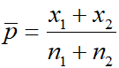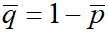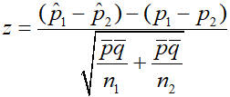 | # One-tailed: H₀:p₁=p₂, H₁:p₁<p₂  x1=12  x2=27  n1=46  n2=43  phat1 <- x1/n1  phat2 <- x2/n2  pbar = (x1+x2)/(n1+n2)  qbar = 1-pbar  z = (phat1-phat2)/ sqrt((pbar*qbar/n1) + (pbar*qbar/n2))  alpha=0.05  z.alpha = qnorm(alpha)  # left-tail# z=-3.49 CV=-1.645 → Reject H₀  # Two-tailed: use qnorm(alpha/2) # z.alpha = qnorm(alpha/2)
CASE 2: | Known σ (Z-test) | 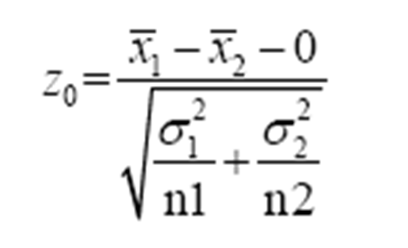 | # H₀:μ₁=μ₂, H₁:μ₁>μ₂, σ=8, n=10 each  xbar1=121  xbar2=112  n1=10  n2=10  sigma=8  var1 = sigma^2  var2 = sigma^2  z = (xbar1-xbar2-0)/ sqrt((var1/n1)+(var2/n2))  # 2.516  z.alpha = qnorm(alpha, lower.tail=FALSE)  # z=2.516 > CV=1.645 → Reject H₀
CASE 3: | Unknown σ, Equal (T-test) | 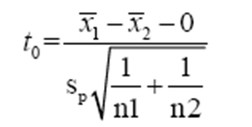  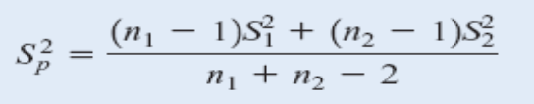 | # H₀:μ₁=μ₂, H₁:μ₁>μ₂, σ=8, n=10 each  xbar1=121  xbar2=112  n1=10  n2=10  sigma=8  var1 = sigma^2  var2 = sigma^2  z = (xbar1-xbar2-0)/ sqrt((var1/n1)+(var2/n2))  # 2.516  z.alpha = qnorm(alpha, lower.tail=FALSE)  # z=2.516 > CV=1.645 → Reject H₀
CASE 4: | Unknown σ, Unequal (Welch) | 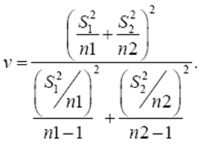  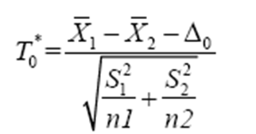 | # H₀:μ₁=μ₂, H₁:μ₁≠μ₂  xbar1=12.5  xbar2=27.5  s1=7.63  s2=15.3  n1=10  n2=10  t0 = (xbar1-xbar2)/ sqrt((s1^2/n1)+(s2^2/n2))  # -2.774  v = ((s1^2/n1)+(s2^2/n2))^2/( ((s1^2/n1)^2/(n1-1))+ ((s2^2/n2)^2/(n2-1)))  # Welch df  t.alpha = qt(alpha/2, floor(v))  # t=-2.77 < CV=-2.16 → Reject H₀

CHAPTER 7: Chi-square Test
->Tests whether observed frequencies differ significantly from expected frequencies.
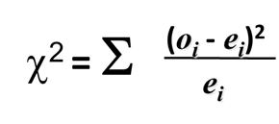
O = Observed frequency
E = Expected frequency
Case No. | Case | Code
Case 1 | Equal Probabilities  H0: P1=P2=P3=P4=P5  H1: At least 1 of the 5 proportions is different from the others | # Accidents on 5 workdays, α=0.05  noAcc <- c(31, 42, 18, 25, 31)  # Quick way – let chisq.test do it all  output <- chisq.test(noAcc, correct=FALSE)  # shows X², df, p-value  str(output)  # shows the structure of output.  output$statistic  output$p.value  output$expected  # Manual way – step by step  expprob <- sum(noAcc)/5  expAcc <- rep(expprob, 5)  #sum up to a x2 statistics  x2 <- sum(((noAcc-expAcc)^2)/expAcc)  alpha <- 0.05  #critical value  x2.alpha <- qchisq(alpha, df=4, lower.tail=FALSE)  #get p-value of x2 of data  x2.pvalue <- pchisq(x2, df=4, lower.tail=FALSE)  # x2=10.65; x2.alpha=9.49; p=0.031  # 10.65 > 9.49 → Reject H₀
Case 2 | Unequal Probabilities  H₀: Proportions match a claimed distribution  H₁: At least one proportion differs | # M&M colours, claimed %: 30,20,20,10,10,10  mnm <- c(33, 26, 21, 8, 7, 5)  prob <- c(0.3, 0.2, 0.2, 0.1, 0.1, 0.1)  # Pass probabilities using p= parameter chisq.test(mnm, p=prob, correct=FALSE)  # X² = 5.95, df = 5, p = 0.311  # p=0.31 > 0.05 → Fail to reject H₀  # Critical value manually  x2.alpha <- qchisq(0.05, df=5, lower.tail=FALSE)  # x2.alpha = 11.07  # 5.95 < 11.07 → Fail to reject H₀
Case 3 | Test of Independence | # Gender vs. Crime Type – Manual Data Frame  male <- c(117, 150, 109, 124)  female <- c(66, 160, 168, 106)  d <- data.frame(male, female)  # perform chi-square test on the data table  chisq.test(d, correct=FALSE)  # X² = 28.51, df = 3, p = 2.84e-06  # p < 0.05 → Reject H₀  # Crime type IS dependent on gender  alpha <- 0.05  x2.alpha <- qchisq(0.05, df=3, lower.tail=FALSE)  # x2.alpha = 7.81
Case 3 | Test of Independence | # From built-in R dataset (MASS library) library(MASS)  tbl = table(survey$Smoke, survey$Exer)  tbl  chisq.test(tbl, correct=FALSE)  # X² = 5.49, df = 6, p = 0.483  # p > 0.05 → Fail to reject H₀  # If warning: cells too small → merge columns  tbl2 = cbind(tbl[,'Freq'], tbl[,'None']+tbl[,'Some'])  chisq.test(tbl2, correct=FALSE)  # X² = 3.23, df = 3, p = 0.357

CHAPTER 8: Correlation & Regression

Part 1 – Correlation Analysis
-> a measure of the statistical relationship between two comparable variables or quantities (bivariate data).

Result: Pearson r, ranges from −1 to +1.
R function: cor(x, y) — the default is Pearson.
Visualise with: plot(x, y)

Example 1 – Positive Correlation (Hours vs GPA)
# Study hours (x) vs GPA (y)
x <- c(42, 23, 31, 35, 16, 26, 39, 19)
y <- c(3.3, 2.9, 3.2, 3.2, 1.9, 2.4, 3.7, 2.5)
# Correlation coefficient
cor(x, y)
# [1] 0.8837 → Strong positive
# Scatter plot
plot(x, y, xlim=c(0,50), ylim=c(0,5), xlab="Study Hours", ylab="GPA")

Example 2 – Negative Correlation (Anxiety vs Exam)
# Test anxiety (x) vs exam score (y)
x <- c(23, 14, 14, 0, 17, 20, 20, 15, 21)
y <- c(43, 59, 48, 77, 50, 52, 46, 51, 51)
# scatter plot
plot(x, y)
# correlation
cor(x, y)
# [1] -0.9124 → Strong negative
# As anxiety ↑, exam score ↓

Part 2 – Regression
-> Finds the best-fit straight line through data points to predict y from x.
Model equation: ŷ = b₀ + b₁x

Example 1 – House Price vs Sq. Feet
# x = square feet, y = price ($1000s)
x <- c(1400, 1600, 1700, 1875, 1100, 1550, 2350, 2450, 1425, 1700)
y <- c(245, 312, 279, 308, 199, 219, 405, 324, 319, 255)
# Build the model
model <- lm(y~x)
model
# shows coefficients
# Intercept: 98.2483
# x (slope): 0.1098
# ŷ = 98.25 + 0.1098x (Linear regression model)
summary(model)
# full stats
# R² = 0.5808 → 58% variance explained
# p-value for x: 0.0104* (significant)
# Scatter plot
plot(x, y, xlim=c(0,2600), ylim=c(0,500), xlab="Square Feet", ylab="Price ($1000)")
# Add the regression line
abline(model)

